Version Update CheckList

- Default table from laravel 11
  - Cache
  - cache_log
  - sessions* $this->validate() have to remove
- Disabled registration page view, maintainance
- Most of the $general variable moved to the gs() function
- frontendImage()
- frontend search keywords
- action attribute should not be empty on form tag
- Should be aware about Intended location
- don't use select tag under ul tag
- Enable Manage template option when you have multiple template
- Be aware of the changes in the social login system if you already have the feature available
- 400,419,500 pages
- Database thike homepage null
- Check subscribe section available or not
- Push notification enable thakle push_script.blade.php file theke ekta HTML content ei div e push hobe. Ei bishoye ektu kheyal rakhben kindly
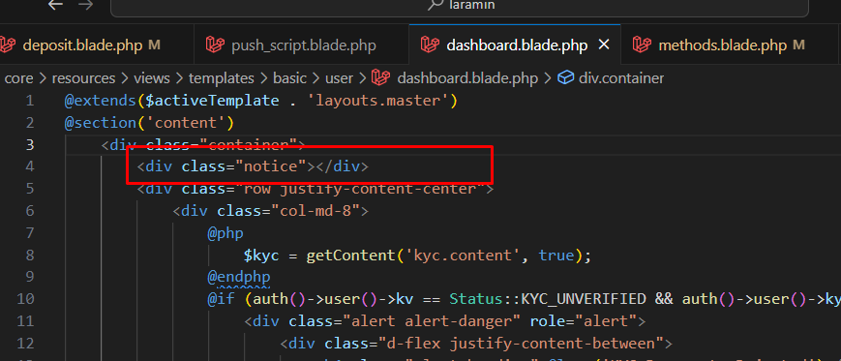

- Blog, policy pages etc, slug making sql required
UPDATE frontends
SET slug = LOWER(REPLACE(REPLACE(REPLACE(
JSON_UNQUOTE(JSON_EXTRACT(data_values, '$.title')), ' ', '-'), ',', ''), '.', ''))
WHERE data_keys = 'blog.element';

UPDATE frontends
SET slug = LOWER(REPLACE(REPLACE(REPLACE(
JSON_UNQUOTE(JSON_EXTRACT(data_values, '$.title')), ' ', '-'), ',', ''), '.', ''))
WHERE data_keys = 'policy_pages.element';

- Mobile App na thakle remove In App purchases
- Users address update
ALTER TABLE `users` CHANGE `address` `old_address` TEXT CHARACTER SET utf8mb4 COLLATE utf8mb4_unicode_ci NULL DEFAULT NULL COMMENT 'contains full address';

ALTER TABLE `users`
ADD COLUMN `address` TEXT NULL AFTER `zip`;

UPDATE `users`
SET
`country_name` = JSON_UNQUOTE(JSON_EXTRACT(`old_address`, '$.country')),
`zip` = JSON_UNQUOTE(JSON_EXTRACT(`old_address`, '$.zip')),
`city` = JSON_UNQUOTE(JSON_EXTRACT(`old_address`, '$.city')),
`state` = JSON_UNQUOTE(JSON_EXTRACT(`old_address`, '$.state')),
`address` = JSON_UNQUOTE(JSON_EXTRACT(`old_address`, '$.address'));

ALTER TABLE `users` DROP `old_address`;

- Add dial.sql
- Add gateways image update (keylab updatesql)
- Add socialite_credentials
UPDATE `general_settings` SET `socialite_credentials` = '{\"google\":{\"client_id\":\"------------\",\"client_secret\":\"-------------\",\"status\":1},\"facebook\":{\"client_id\":\"------\",\"client_secret\":\"------\",\"status\":1},\"linkedin\":{\"client_id\":\"-----\",\"client_secret\":\"-----\",\"status\":1}}' WHERE `general_settings`.`id` = 1;

- Add Automatic cron modal popup
- Check available_version in general settings, if null, set it to 1
- CHECK REGISTER DISABLE BLADE
- Frontend keywords
- Commented out codes, dd, dump , console.log, {{--
- Helpers version check/update
- Check error logger https://cs.viserlab.com/errorlogger/admin
- asd

